Becker Lab: Head and Neck Pathology
The Head and Neck Pathology Group at the Institute of Pathology of the University Medical Center Rostock specializes in diseases of the head and neck region. These include tumors and non-neoplastic changes of the lip, oral cavity, oropharynx, larynx, and salivary glands. Since its establishment in 2022, the group has benefited from the comparatively high incidence of non-cutaneous squamous cell carcinoma (HNSCC) in the head and neck region compared to the national average. Carcinomas associated with tobacco and alcohol consumption are disproportionately common in the Mecklenburg-Vorpommern region, whereas HPV-associated carcinomas, caused by an oncogenically transforming HPV high-risk infection, are comparatively rare.
The focus is on squamous cell carcinomas and their precursor lesions, especially those of the oral mucosa. We investigate oral potentially malignant diseases, including oral lichen planus and common oral epithelial dysplasia, based on morphomolecular progression mechanisms, including the p53 signature, with regard to the risk of malignant transformation. This research is conducted in close collaboration with the MKG of the UMR (https://mkg.med.uni-rostock.de/forschung/forschungsschwerpunkte).

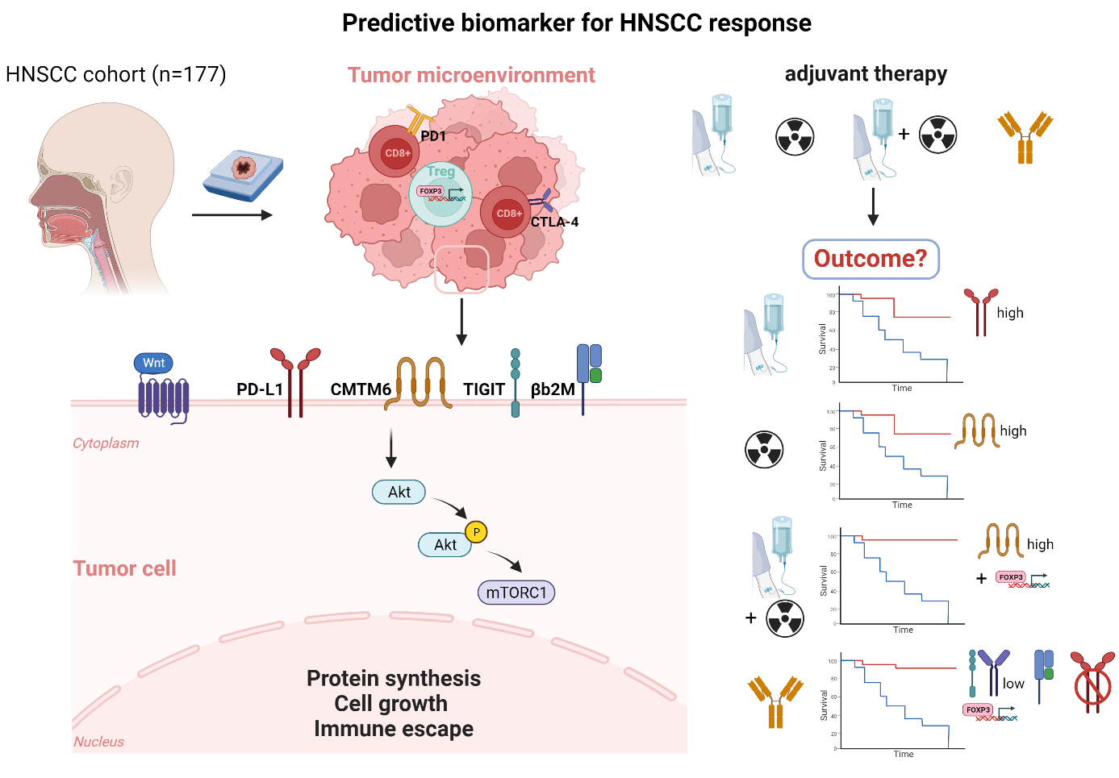
We examine prognostic and predictive markers in tissue samples of already diagnosed or invasive head and neck squamous cell carcinoma (HNSCC), using classical morphological and molecular research approaches. This research is conducted in collaboration with the ENT Clinic "Otto-Körner" at the UMR (https://hno.med.uni-rostock.de/forschung). The laboratory of the Clinic and Polyclinic for Hematology, Hemostaseology, Oncology, Stem Cell Therapy and Palliative Medicine, led by Dr. Claudia Maletzki, tests functional therapeutic approaches as translational research (https://onkologie.med.uni-rostock.de/forschung/ag-leukaemie/team-der-ag-leukaemie). The mechanisms of immune control and immune escape under immune checkpoint inhibitor therapy in HNSCC are examined to better understand the etiology, pathogenesis, and response to therapy.
In future projects, the lab will continuously integrate AI-based algorithms to optimize diagnostic workflows and patient care. This can be done in part by using software tools from a private pathology practice (https://patho-praxis-gue-hro.de/).
The team consists of employees of the Institute of Pathology and (dental) medical doctoral students.

Medical dissertations:
Medical doctorates are often awarded to individuals interested in pathology. Candidates are asked to send an email requesting this. Supervision is usually one-on-one, with the goal of presenting the doctoral thesis at the annual congress of the German Society of Pathology (https://www.pathologie-dgp.de/die-dgp/arbeitsgemeinschaften/kopf-hals-pathologie/). There are regular meetings for scientific exchange and informal get-togethers to ensure a good atmosphere.
Company run June 2023: 
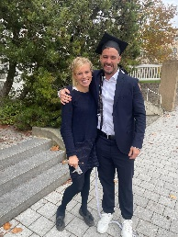
October 2024: Congratulations to Dr. C. Schofeld on the successful defense of his doctoral thesis “CKLF-like MARVEL transmembrane domain containing Protein 6 (CMTM6) als prognostischer Biomarker im nicht-kutanen Plattenepithelkarzinom des Kopf-Hals-Bereichs”
Current medical doctoral students:
- Karolin Folkers
- Cornelius Kluge
- Maximiliane Holm
- Jennifer Merkl

Cooperation partners outside the UMR:

Ko, Yen Chen Kevin, MD, DMD, Department of Pathology and Laboratory Medicine, University of British Columbia, Canada
https://pathology.ubc.ca/2022/12/01/yen-chen-kevin-ko/
Dr. Dr. med. Andreas Mock, Institut für Pathologie LMU München https://www.med.lmu.de/pathologie/de/forschung/ag-mock/
PD. Dr. med. Annette Zimpfer, Institut für Pathologie Universität des Saarlands https://www.uks.eu/kliniken-einrichtungen/pathologie-rechtsmedizin/allgemeine-spezielle-pathologie/team
PD. Dr. med. Christian Idel, HNO-Klinik UKSH Campus Lübeck https://www.uksh.de/hno-luebeck/Wir+%C3%BCber+uns/Unser+Team/Ober%C3%A4rzte.html

Link Pubmed-Verzeichnis: https://pubmed.ncbi.nlm.nih.gov/?term=Anne-Sophie+Becker+rostock

